Steps to be completed by the insurers before the AssurPharma Technical Workshop
- eHealth certificates request:
- Prerequisites:
  - java 1.6 (NOT higher)
  - eID card + eID card reader
- Surf to http://wwwacc.ehealth.fgov.be/JWS/ETEE/etee-requestor_nl.jnlp and install the eHealth certificate manager. This tool will be used to request the necessary eHealth certificates.
- Follow the on-screen instructions.
Every insurer should request one “organization certificate” and at least one personal certificate, according to the tables below:
Personal certificates:
INSZ_NISS | FIRST NAME | NAME | RIZIV-INAMI N°  as pharmacist
84020732579 | Pieterjan | Vanpee | 2-20701-71-001
84051837907 | Tim | Wouters | 2-20702-70-001
74101902361 | Thierry | Bertholet | 2-20703-69-001
69021010390 | Karl | Vandecasteele | 2-20704-68-001
71051237119 | Mario | Di Francesco | 2-20705-67-001

Organisation certificates (should be requested by the pharmacy-holder!)
Pharmacy N° | Pharmacy Name | Pharmacy holder SSIN | Pharmacy holder Name | Pharmacy holder last name
2-99003-48 | APO ASSU 0739 | 84020732579 | Pieterjan | Vanpee
2-99004-47 | APO ASSU 0079 | 69021010390 | Karl | Vandecasteele
2-99005-46 | APO ASSU 0196 | 74101902361 | Thierry | Bertholet

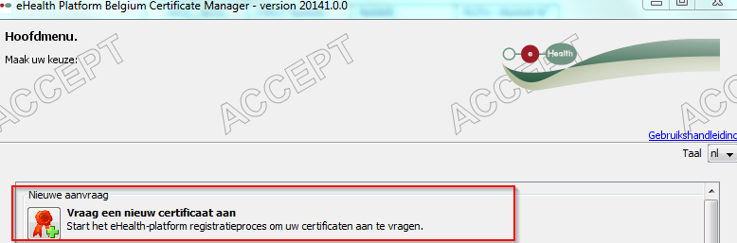
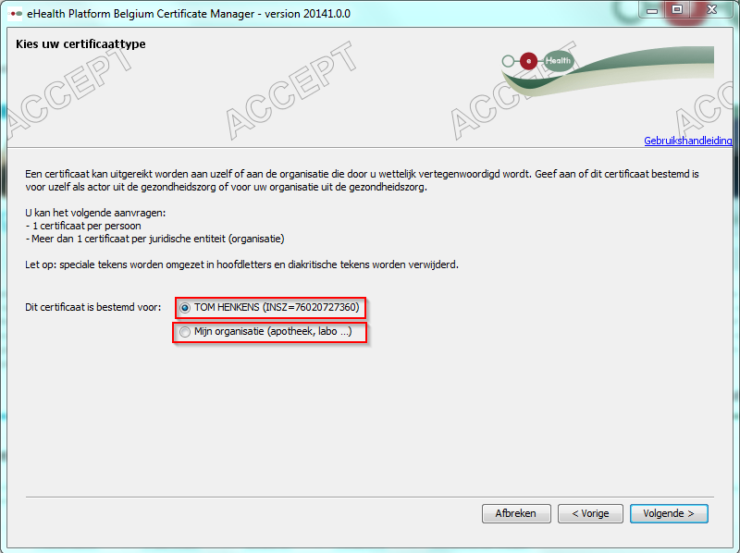
- For the organization certificate (=pharmacy certificate): a default pharmacy should be presented. Select this one and DON’T tick the other boxes.
- After having gone through the first phase of the request procedure, a confirmation mail will be send by eHealth asking you to go through phase 2 of the certificate request procedure. Phase 2 should be completed for every certificate.
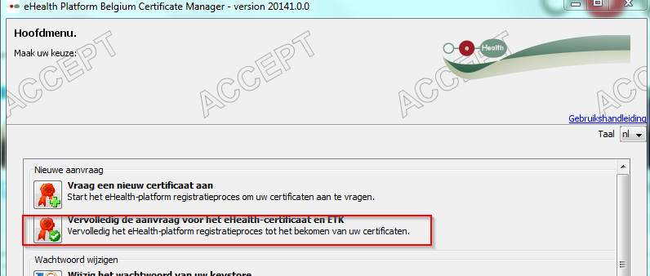
- You should now be in possession of the necessary eHealth certificates. Bring them to the minilab and be sure to remember the password.
- Installation of the SDK executor tool.
- Prerequisites (for the GUI executor tool):
  - .NET version 4 or higher
- The SDK executor tool v1.4.0 can be found on the APB ftp server (credentials will be send soon in a separate mail), in the folder Projects/Assurpharma
- Unzip the files
- run /examples/gui/setup.bat
- run /examples/gui/startGui.bat
- When everything is fine, the following screen should be presented.
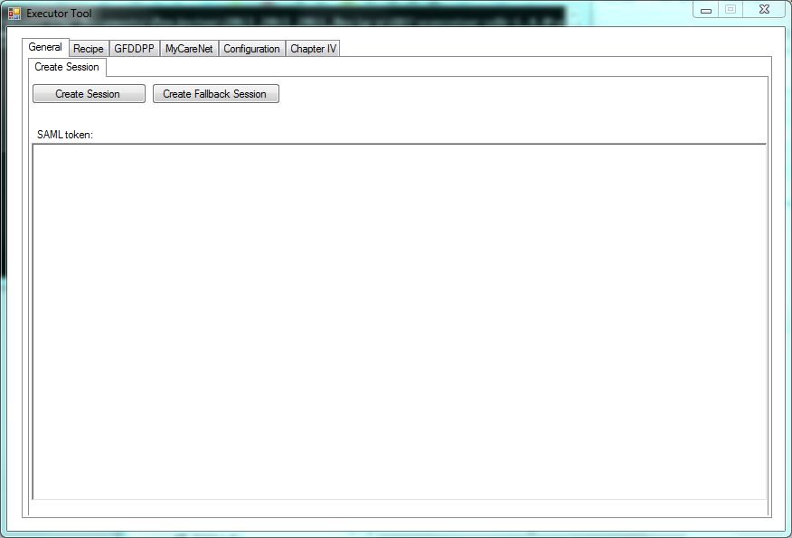
- Further configuration will be done at the Technical Workshop itself.
Please verify if you are allowed to call http and https webservices.
If you have to go through a proxy server, bring your proxy parameters with you

- Support
In case of problems, contact tom.henkens@apb.be

